“Your training data is store-week, but media & macro are market-week. How do you handle that?”
We align everything to the finest decision grain and treat higher-level data as shared exposure.
Market-week media and macro variables are broadcast to all stores in that market for the week. Store-level fixed effects then ensure we’re learning within-store responses, not confusing cross-market differences with driver impact.

VIF measures whether features are overlapping so much that the model can’t tell them apart.
A high VIF doesn’t mean the feature is wrong—it means it’s redundant with others, which can make coefficients unstable and flip signs.
Why execs should care
- High VIF → unstable coefficients
- Unstable coefficients → inconsistent “top drivers”
- VIF is about interpretability and trust, not accuracy
Simple definition
$$\text{VIF}=\frac{1}{1-R^{2}}$$
- If a feature can be predicted by others → VIF goes up

Method | What it does | When we use it
Fixed Effects (FE) | Compares each store to itself | Default, most stable
Mundlak (CRE) | Separates within-store vs between-store effects | Robustness / interpretability
Hierarchical Bayesian | Allows store-specific responses with shrinkage | Sparse segments, deep dives

# Within-store demeaning (FE)
df["y_dm"] = df["log_sales"] - df.groupby("store_id")["log_sales"].transform("mean")
df["media_dm"] = df["log_media"] - df.groupby("store_id")["log_media"].transform("mean")

Ridge(alpha=10).fit(df[["media_dm"]], df["y_dm"])

# Mundlak means
df["media_store_mean"] = df.groupby("store_id")["log_media"].transform("mean")

X = df[["log_media", "media_store_mean"]]
Ridge(alpha=10).fit(X, df["log_sales"])

beta_store ~ Normal(beta_global, sigma)
log_sales_it = beta_store * log_media_it + ...

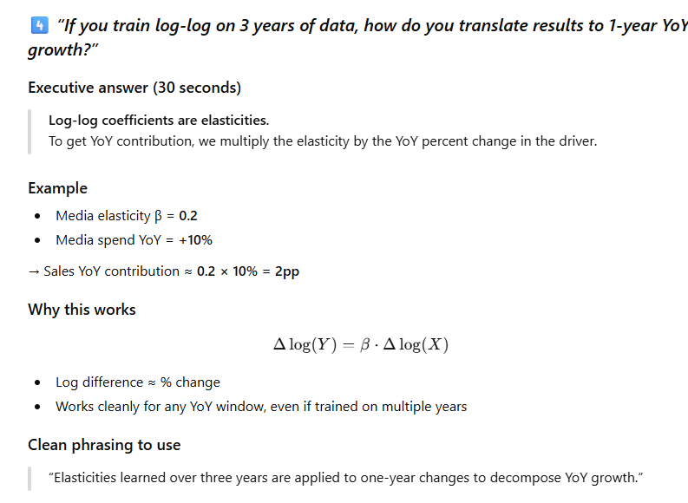

5️⃣ “You run heavy experiments across feature subsets—what about cost?”
Executive answer (30 seconds)
We manage cost by structuring experiments, not brute-forcing everything.
Pre-selection collapses 400 features to ~80, then experiments vary blocks and assumptions, not random combinations.
Why cost stays controlled
- Experiments are parallelizable (Databricks)
- Models are linear / regularized, not deep nets
- Feature blocks reduce combinatorics
What we do not do
❌ Randomly sample hundreds of feature subsets
❌ Tune dozens of algorithms
❌ Optimize purely on accuracy
How you can summarize
“We trade uncontrolled feature explosion for structured experimentation that prioritizes stability and interpretability.”

